**Facilitate communication and collaboration:**

1. Starting with Azure DevOps services
2. What are Azure Boards

**Drill 1 - Working with Azure Boards**

* Login to your azure devops
* Click on create a new project to access all the objects like (Azure boards, repos, files etc)

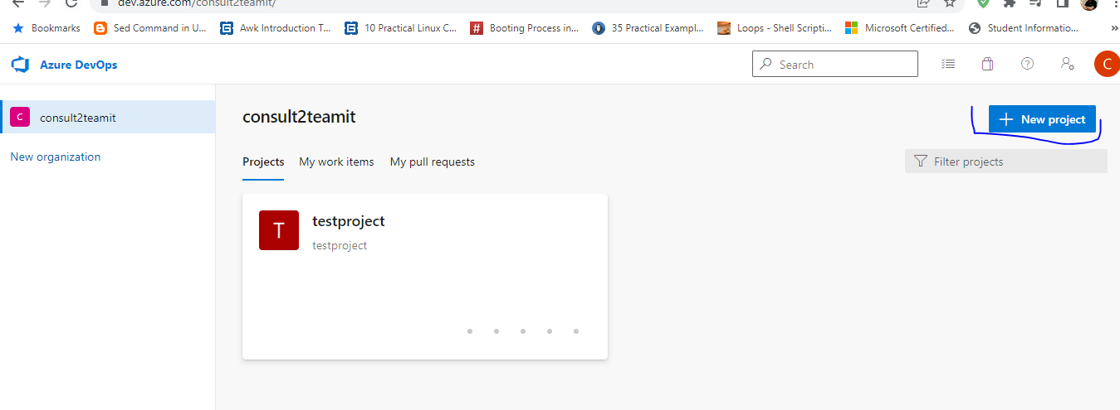

During the creation of project you have to select team foundation, as it contains **git** itself.

Once done you will get screen like this.

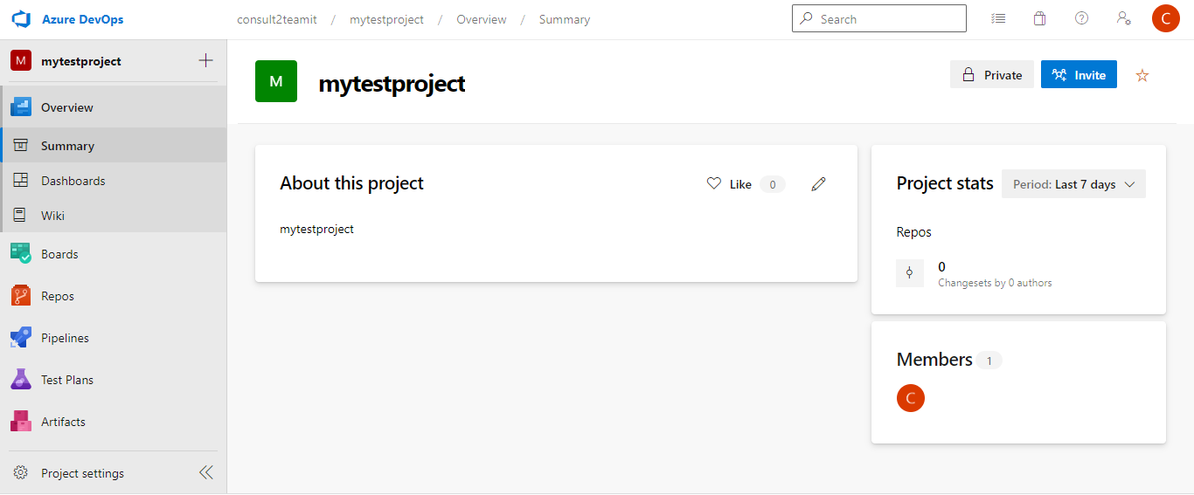

Click on Boards 🡪 create an issue under boards and fill other details.

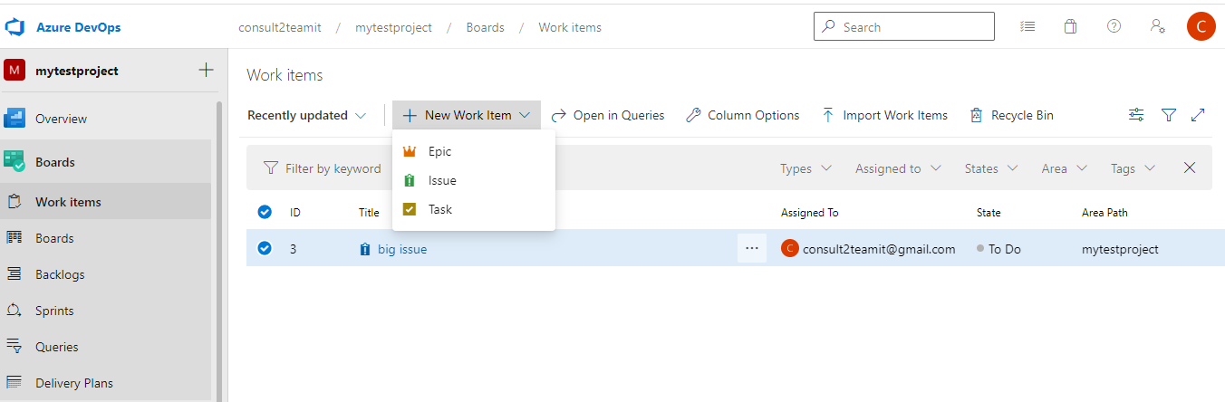

Further we can explore 🡪 Work item , Boards, Backlogs and also we can create a Sprint.

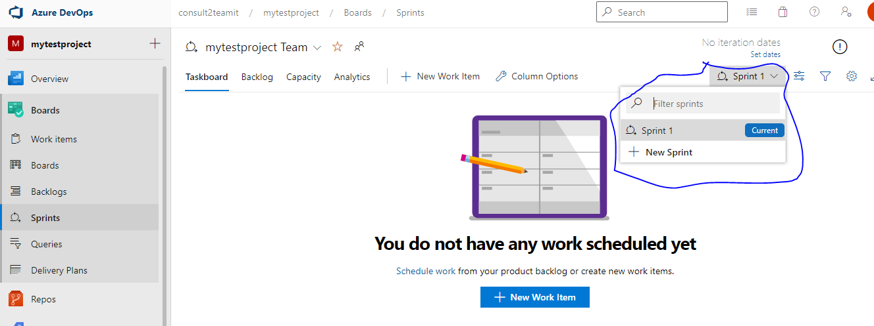

**Drill 2 – Azure Boards – How to add users in team**

To add new user first go to project then go to Organization settings

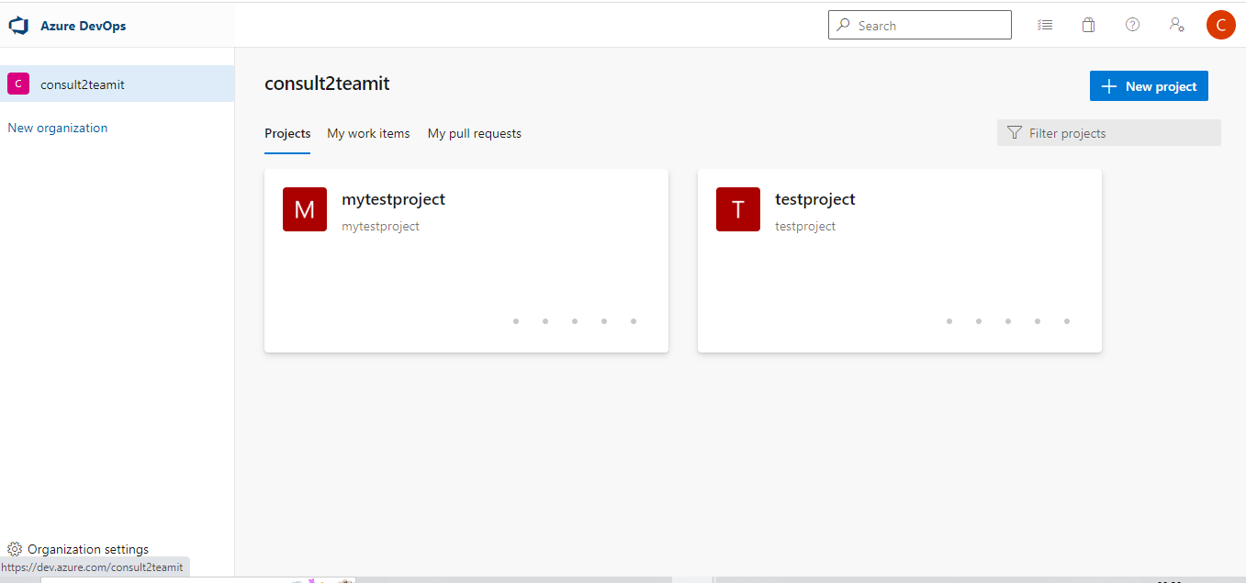

In Pannel we will see Users option, we have to fill all the details. 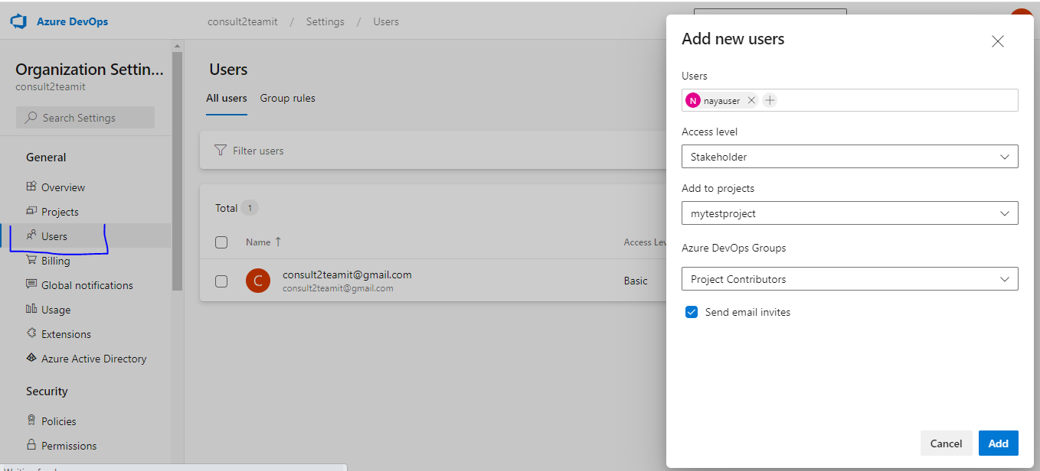

Once done with all these details , Go to project and click on project settings.

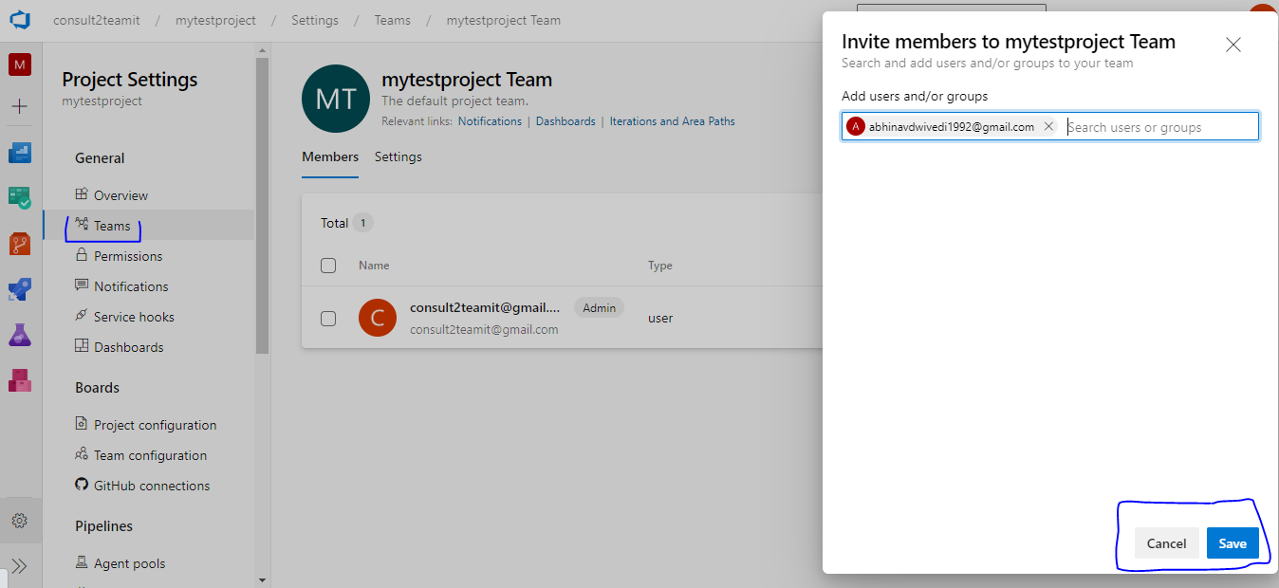

You will get invitation over the email, so click on Join now and go back to the boards and try to change username in work items.

**Drill 3 – Azure Boards – Charts**

Click on Queries , go to New Query 🡪Editor 🡪 Run Query 🡪 Save Query 🡪 Go to New charts and fill the conditions.

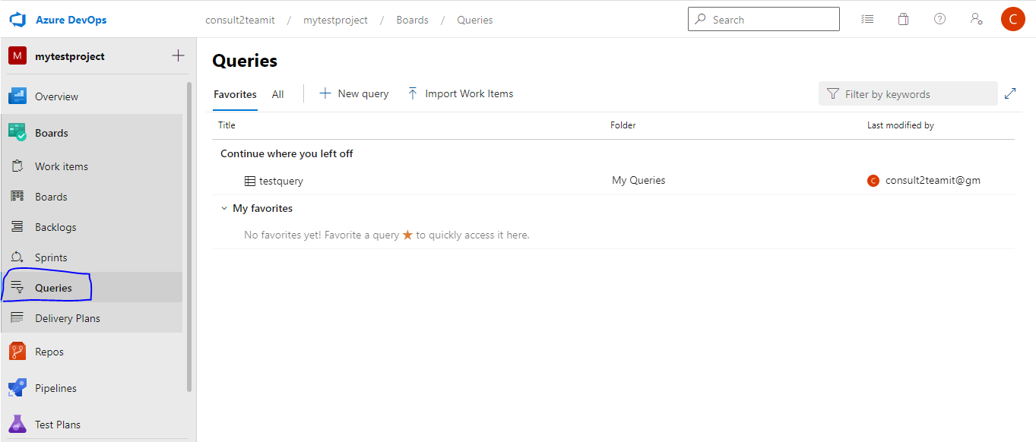

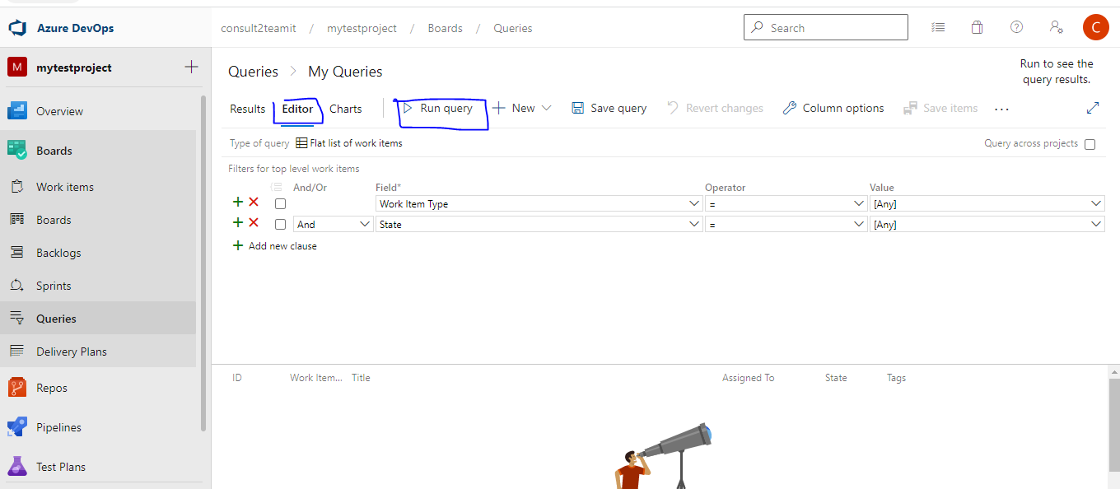

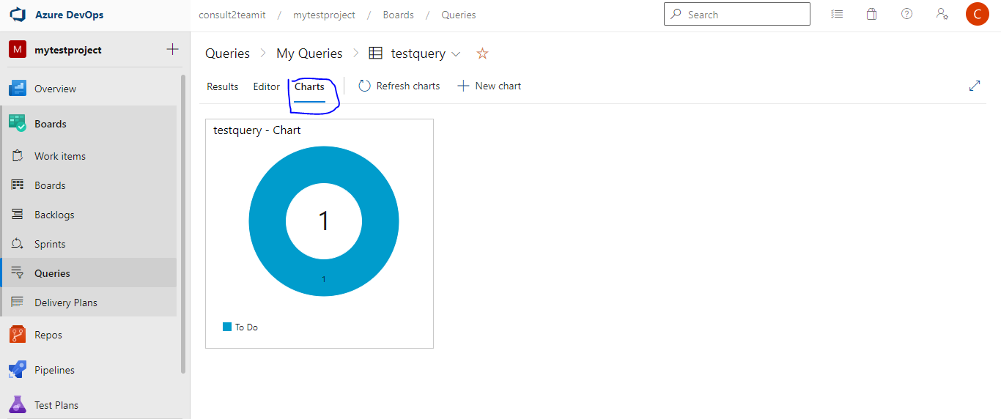

**For Associates - Exercise – How to add charts into Dashboards.**